
www.wafarmersmarkets.org | February 2025

Food Access Signage Check List
Having clear and consistent signage helps your shoppers can easily navigate your farmers market and use their food access currencies. Signage may also be a requirement of the food access program.
Program | Image | Placement | Notes & Tips | Where to Get Signs
WIC & Senior Farmers Market Nutrition Program (FMNP) | 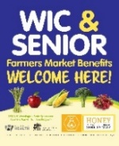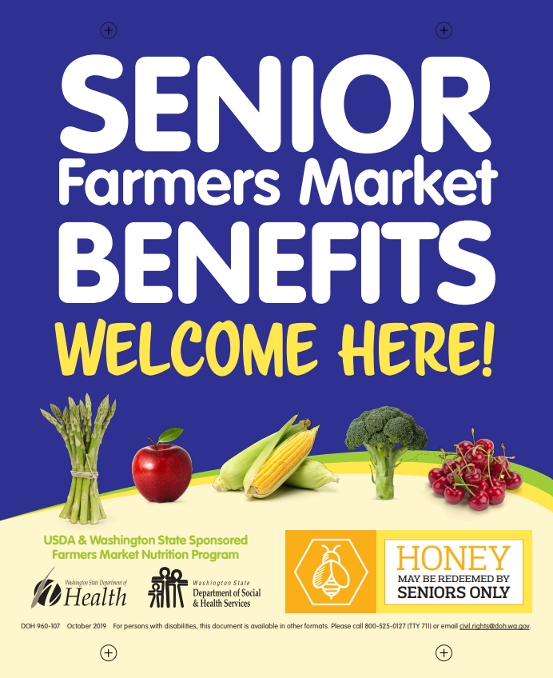 | - Grower Booth required if grower is authorized to accept FMNP  - Info Booth recommended | There are directions printed on the back of signs. The Senior FMNP sign is for HONEY vendors only.  June to October. | DOH, FMNP Team  Call (800) 841-1410 Email FMNPTeam@doh.wa.gov
WIC Fruit and Vegetable Benefit | 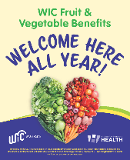 | - Grower Booth recommended  - Info Booth recommended | This benefit started being accepted at farmers markets in 2023 and is still new to growers and shoppers.  Accepted year-round. | DOH, FMNP Team  Call (800) 841-1410 Email FMNPTeam@doh.wa.gov
SNAP EBT  A-board | 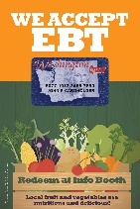 | - At farmers market entrance(s) recommended | More than one A-board may be needed if farmers market has multiple entrances.  SNAP Market Match and SUN Bucks stickers are available to put on these A-boards. | DOH, SNAP Market Match  Or WSFMA
SNAP EBT  Banner | 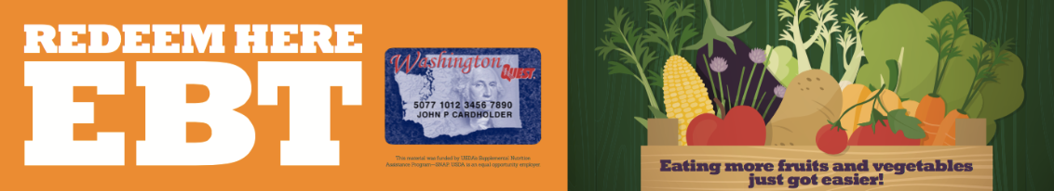 | - At Info Booth recommended | Measures 2 feet x 10 feet | DOH, SNAP Market Match  Or WSFMA
SNAP EBT “Accepted Here | 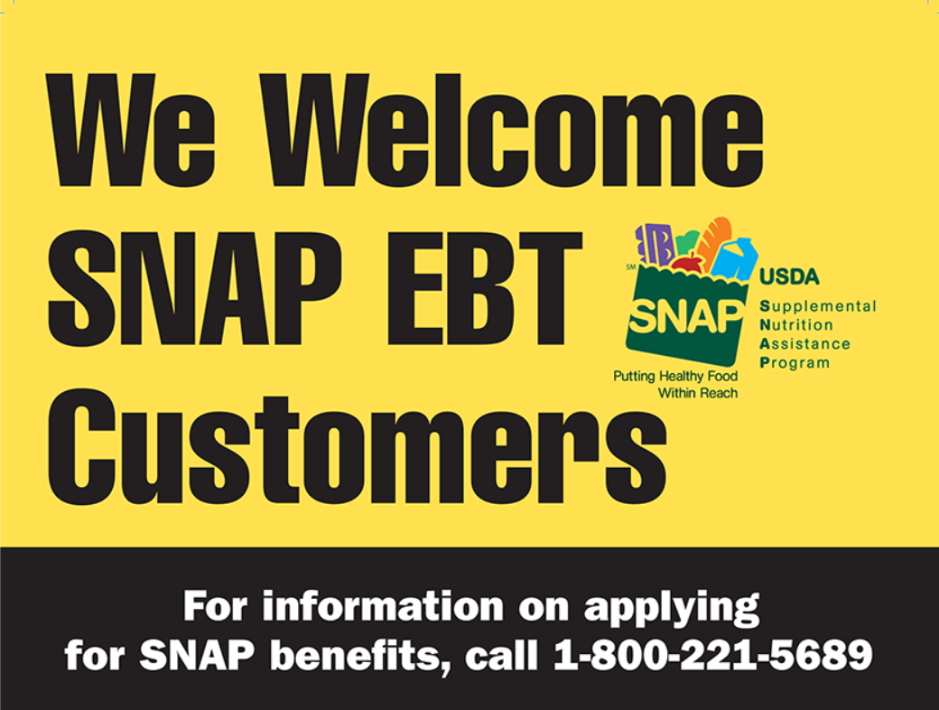 | - Info Booth, required | There are a variety of these signs that can work. Important thing is to be sure to have one of them. | USDA FNS  goEBT.com, Shop
SNAP Market Match | 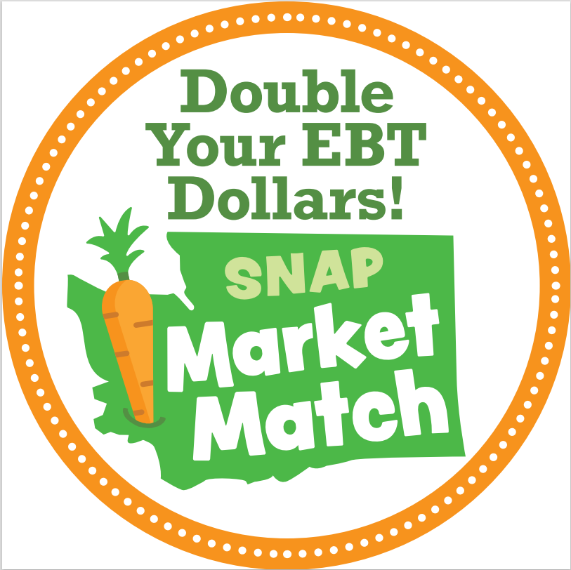 | - Stick on SNAP EBT A-board, recommended | This is an 8-inch sticker | DOH, SNAP Market Match  Call (360) 236-3148  Email SNAP.MarketMatch@doh.wa.gov
SNAP Markt Match | 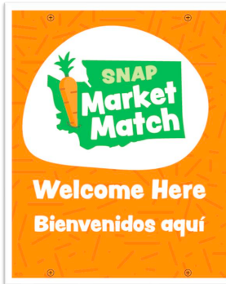 | - Vendor booth: required if selling eligible products  - Info Booth recommended |  | DOH, SNAP Market Match  Call (360) 236-3148  Email SNAP.MarketMatch@doh.wa.gov
SUN Bucks or Summer EBT |  | - Stick on SNAP EBT A-board, recommended | This is an 8-inch sticker | WSFMA
Add any other food access programs your market manages to this table.

Please note that the abundance of signage from all the different food access programs is usually confusing to your market volunteers, shoppers, and growers. We recommend promote your food access programs as a bundle or “menu” of options rather than individually. This makes it easier for your shoppers, volunteers, market staff, and vendors to see everything you available in one place.

Recommended resource: “Guide to Fresh Produce Signage Standards and Organic Integrity” from the WSFMA. Available as hard copy from the WSFMA and on WSFMA website (In Vendor Resources) in English and Spanish.

