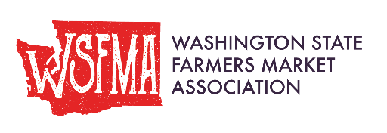
www.wafarmersmarkets.org
April 2024

FOOD ACCESS PROGRAMS

Information Management Templates for Farmers Markets

Handy Tips for Ongoing Operations & Transitions

Need Help?
The WSFMA and our “Regional Leads” are available to help with any food access questions. There is a Regional Lead assigned to every County. Please search Food Access materials and Regional Leads on www.wafarmersmarkets.org, email foodaccess@wafarmersmarkets.org or call (206) 706-5198 for help.

Your Farmers Market’s Food Access Programs
Participating in the Washington state food assistance programs is voluntary. Note if and when your market has participated in any of these programs to log your market’s history.

Program | Year this FM started offering | Currently offering? | Who is managing program for market
FMNP WIC and Senior
SNAP EBT
SNAP Market Match
Fresh Bucks (City of Seattle)
Power of Produce (POP)
Add other programs

Many of these programs have required, annual trainings and it is helpful to know where training materials are stored, who attended, and when.

Key Contacts and Program Managers

Farmers Market Nutrition Program

General email: FMNPteam@doh.wa.gov
General phone: (800) 841-1410
www: https://doh.wa.gov/public-health-provider-resources/public-health-system-resources-and-services/local-health-resources-and-tools/wic/training/training-materials/farmers-market-training-materials

Katherine D. Flores
Farmers Market Nutrition Program Lead and WIC FMNP
Office of Nutrition Services
Washington State Department of Health
Katherine.Flores@doh.wa.gov
(360) 236-3721

Cameron Akita
Senior Farmers Market Nutrition Program Manager
State Unit on Aging, Aging and Long-Term Support Administration
Washington State Department of Social and Health Services
cameron.akita@dshs.wa.gov
(360) 725-2466

SNAP EBT

Sharon Hill-LaGuerre
EBT /EFT Lead Program Manager
Community Services Division | Economic Services Administration
Washington State Department of Social and Health Services
Sharon.Hill-LaGuerre@dshs.wa.gov
(360) 870-9316

Amber Foister
EBT Retail & Security Program Manager / Community Services Division
Economic Services Administration
Washington State Department of Social and Health Services
amber.foister1@dshs.wa.gov
(360) 790-1055

SNAP Market Match

Amanda J. Weyrauch
Farmers Market Specialist
SNAP Market Match
Fruit & Vegetable Incentive Program
Washington State Department of Health
amanda.weyrauch@doh.wa.gov
(360) 485-6430 cell

SNAP EBT Equipment
Managing SNAP EBT and credit/debit card Point of Sale (POS) equipment can be a challenge. There are many types and programs that farmers markets use. Having your SNAP EBT equipment information in one place is helpful when calling customer service and logging your inventory.

Company
Card Reader: Make and Model
Serial Number
Customer or Tech Support Phone
Email
Web support
When acquired
Where acquired
History of issues?

- Account Number:
- Length of Contract/Grant Funding, if applicable:
- Date of Contract Signing:
- Contact/Signer on the Account (Full Name & Title):
- Email Address associated with account:
- PCI Compliance (Expiration/Notes):
- Expected/Anticipated Costs (Annual/monthly fees):
- How do you receive monthly statements and where are they sent?:

SNAP Bank Account Information

Name of bank
Last 4 digits of bank account number
How are statements received? What email or physical address are they sent to?
Notes

Authorized Signers on the SNAP Bank Account
Name | Title | Phone | Email

SNAP FNS Permit
To offer SNAP at your farmers market, you need to become an Authorized SNAP Retailer. This requires submitting an application and getting a permit from the USDA Food and Nutrition Service (FNS). Keeping track of FNS Permit information is very important. All information should be noted exactly as the information is listed on your SNAP permit. Any changes must be reported to USDA FNS by calling (877) 823-4369. The USDA’s SNAP Retailer Service Center has more information: Fns.usda.gov/snap/RSC.

Information | Your Permit
Where is the FNA Application and Approval Letter stored?
7-digit FNS Permit Number
Location name
Location of SNAP Site
Full name and title of signer of application “owner”
Contact information for “owner”
Full name and title of signer any other “owners” listed in application
Contact information any other “owners” listed in application
Date of the application was submitted
Mailing address listed in application
Email address listed in application

SNAP & CREDIT/DEBIT TOKENS
Tokens are real currency and should be managed with the same care as money.

Supplier
Cost of tokens
Token details (size, material, ink color, denominations)
How many have been printed (quantity and value)?
Storage location?
Who is responsible for token management?
Notes

SNAP Market Match
Farmers markets that offer SNAP can apply to participate in the Department of Health’s SNAP Market Match program. This is an incentive program to provide matching funds to buy produce.

Program website: https://doh.wa.gov/you-and-your-family/nutrition-and-physical-activity/healthy-eating/snap-match-programs/snap-market-match/farmers-market-information

Market Incentives Manager
If your farmers market has created its own incentive program or added to SNAP Market Match, note here.

Name of Incentive
Currency used
Amount given
When given
When can be used: All season? Limited time?
What can it be used to buy
Funders
Key contacts

Name | Funder/Partner | Phone | Email

Market Currencies Manager
If your farmers market has created its own currency or is using a currency from another program, like KERNEL or POP, then note the name(s) of the person who is in charge of the program(s) here.

Name | Currency | Phone | Email

Food Access Signage Check List
Not only is food access signage required by the program, it is vital to ensure your shoppers can easily navigate your farmers market. If you see signage on this list that you do not have, use the contact information to order or re-order signage for your market. Add any additional signs that your market uses: Fresh Bucks, POP, KERNEL, etc.

Program | Image | Placement | Notes & Tips | Where to Get Signs
WIC & Senior Farmers Market Nutrition Program (FMNP) | 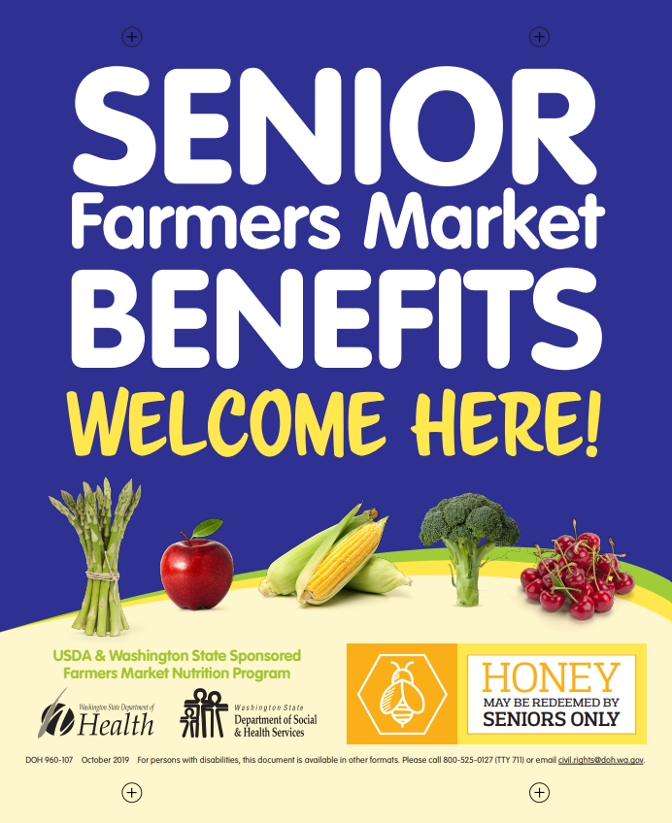 | - Grower Booth required if grower is authorized to accept FMNP  - Info Booth recommended | There are directions for signs on the back of them. The Senior FMNP sign is for HONEY vendors only.  Tip: Have extras on hand for farms that forget their signs. | From the FMNP Team:  fmnpteam@doh.wa.gov  (360) 236-3721 or (800) 841-1410  You can order as many signs as needed.
WIC Fruit and Vegetable Benefit | 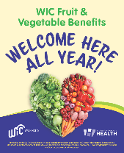 | - Grower Booth recommended  - Info Booth recommended | This program started at farmers markets in 2023 and is still new to growers and shoppers. | Same as FMNP
SNAP EBT  A-board | 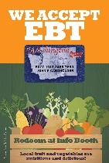 | - At farmers market entrance(s) recommended | More than one A-board may be needed and should be available. | Amanda Weyrauch  SNAP Market Match  amanda.weyrauch@doh.wa.gov  (360) 485-6430  Or the WSFMA
SNAP EBT  Banner | 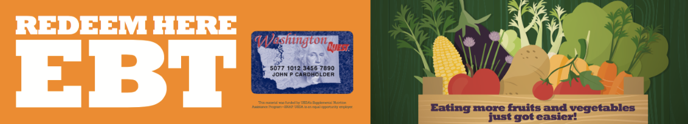 | - At Info Booth recommended | Measures 2 feet x 10 feet | Same as the SNAP EBT A-board.
SNAP EBT “Accepted Here | 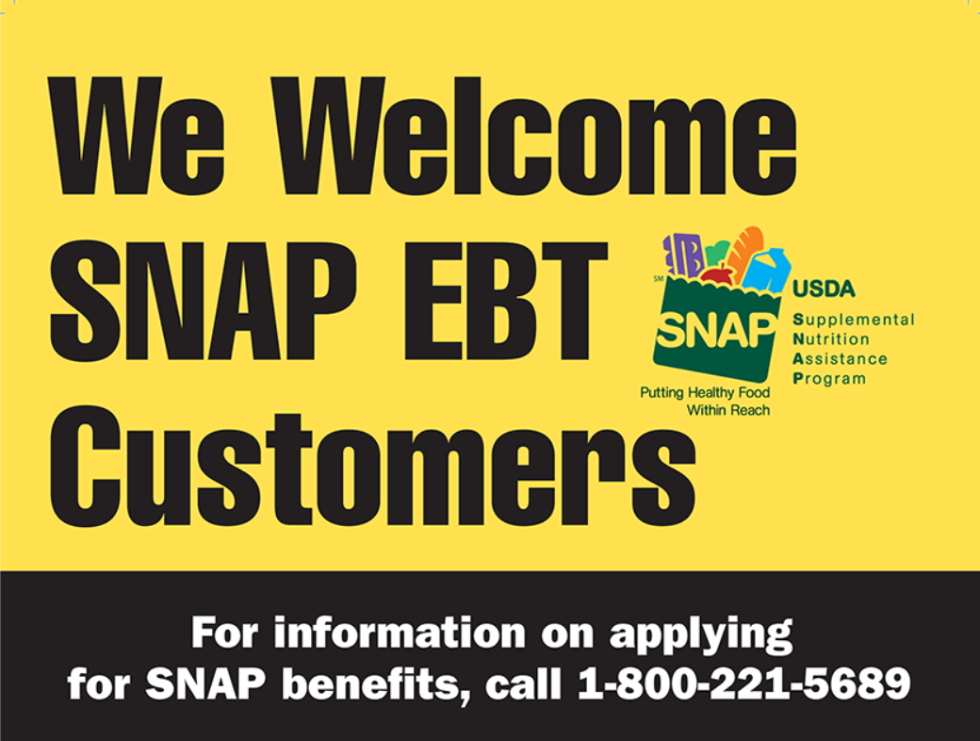 | - Info Booth, required | There are a variety of these signs that can work. Important thing is to be sure to have one of them. | USDA Food and Nutrition Services (FNS).
SNAP Market Match | 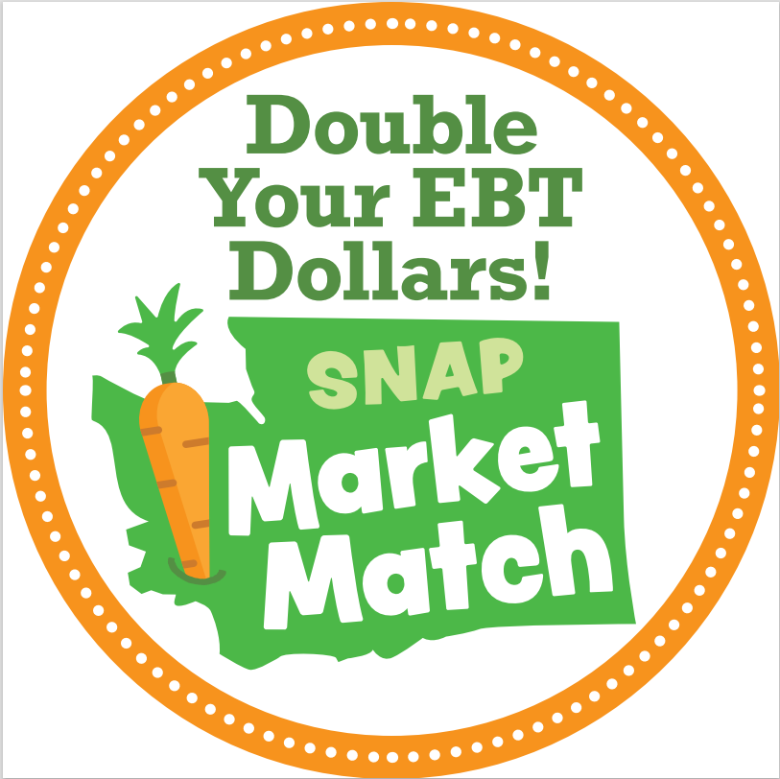 | - Stick on SNAP EBT A-board, recommended | This is an 8-inch sticker | Amanda Weyrauch  SNAP Market Match  amanda.weyrauch@doh.wa.gov  (360) 485-6430
Add any other food access programs your market manages here!

Please note that the abundance of signage from all the different food access programs can be confusing to your market volunteers, shoppers, and growers. Best Practice: Promote your food access programs as a bundle rather than individually. This makes it easier for your shoppers, volunteers, market staff and growers to see everything you offer in one place.

Recommended resource: “Guide to Fresh Produce Signage Standards and Organic Integrity” from the WSFMA. Available as hard copy from the WSFMA and on WSFMA website (In Vendor Resources) in English and Spanish.

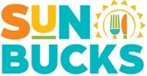 “SUN Bucks” is a new, permanent version of the “Summer EBT” program which provides $120 in benefits that can be spent at farmers markets. They also can be matched by SNAP Market Match. School age youth who are participate in free and reduced lunch will be automatically enrolled in SUN Bucks. The signage for SUN Bucks is not yet designed. Updates to follow as soon as any information is available.

