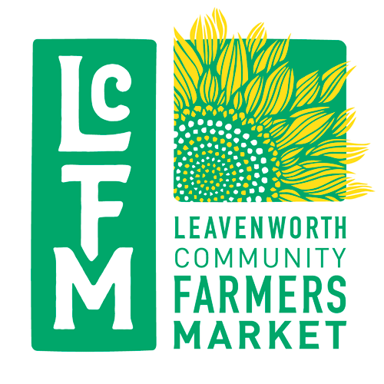 | end of the year report 2021  vs# <<vs>>  Date: 10/25/2020
To:  <<vendor>>  <<contact>>  <<PHONE>> | From:  Leavenworth Community  Farmers Market

<<vendor>>: Season Sales Totals 2021
Number of Markets Attended | FMNP WIC Vouchers | FMNP  Senior Vouchers | Credit Card  Tokens (green) | SNAP EBT Tokens  (red) | SNAP Market Match Vouchers | Total reimbursed for Tokens & EBT | Total fees paid to LCFM | Total Market Sales 2021
<<markets>> | <<WIC>> | <<Senior>> | <<Credit>> | <<EBT>> | <<Match>> | <<reimbursed>> | <<owed>> | <<total>>

6/3 | 6/10 | 6/17 | 6/24 | 7/1 | 7/8 | 7/15 | 7/22 | 7/29 | 8/5
<<1>> | <<2>> | <<3>> | <<4>> | <<5>> | <<6>> | <<7>> | <<8>> | <<9>> | <<10>>

8/12 | 8/19 | 8/26 | 9/2 | 9/9 | 9/16 | 9/23 | 9/30 | 10/7 | 10/14
<<11>> | <<12>> | <<13>> | <<14>> | <<15>> | <<16>> | <<17>> | <<18>> | <<19>> | <<20>>
Thank you for another great year !

