###### Virginia Mason Medical Center, 925 Seneca Street, Seattle, WA 98101 VirginiaMason.org

July 26, 2013

This Week at the Market



Virginia Mason is committed to Healthy Communities

**Health Highlight: Kale**

The Aggregate Nutrient Density Index (ANDI) is a score assigned to whole foods that contain the highest nutrients per calorie. This system was developed by Dr. Joel Fuhrman, author of Eat For Health and Eat Right America Nutritarian Handbook. Each whole food is given a score between 0-1,000, with 1,000 being the most nutrient dense.

Kale, along with collard greens and watercress, received an ANDI score of 1,000, labeling it as one of the most nutrient foods you could choose.

This nutritional powerhouse is an excellent source of Vitamins A, K and C as well as the mineral manganese. It is a very good source of fiber, copper, tryptophan, calcium, vitamin B6 and potassium. Kale is a great source of anti-inflammatory nutrients, antioxidants, essential micronutrients as well as glucosinolates, compounds found in cruciferous vegetables that have been proven to be protective against cancer.

According to a 2013 report by the Environmental Working Group (EWG), conventionally grown kale is often contaminated with concentrations of insecticides. The EWG recommends choosing organically grown kale whenever possible.

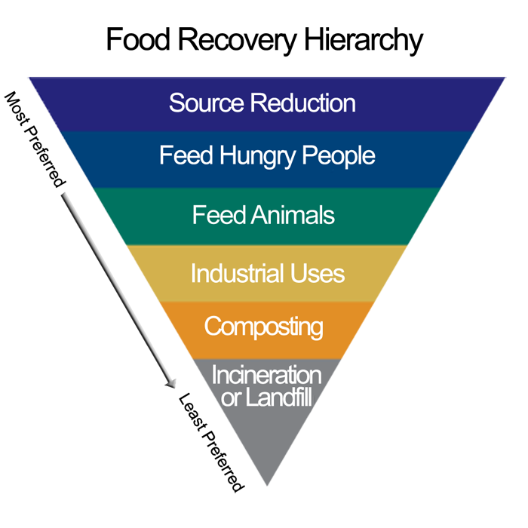

EnviroMason and the Food and Nutrition Department at Virginia Mason have signed onto the **Food Recovery Challenge** through the Environmental Protection Agency (EPA).



This is a commitment to reduce as much food waste as possible, helping the community and protecting the environment.

When food waste is thrown into the landfill, it produces methane, which is known to be a potent greenhouse gas. According to the EPA, in 2011 almost 36 million tons of food waste was thrown into landfills. In this same year 14.9 percent of U.S. households did not know where their next meal would come from.

The Food Recovery Challenge supports businesses and organizations in addressing the issue of food insecurity while simultaneously reducing their greenhouse gas emissions.

At Virginia Mason, we participate in the Food Recovery Challenge by donating excess food to the Millionair Club Charity, a local organization that provides meals, jobs and assistance to people in need.

Food waste is collected in our cafeteria and composted by Cedar Grove. Composting creates a healthy and rich soil amendment which supports future growth while preventing this organic matter from ending up in landfills.

**The Virginia Mason Farmers Market**

**Is sponsored by EnviroMason**

**VirginiaMason.org/enviromason**



**For more information on what’s fresh and local visit pugetsoundfresh.org**

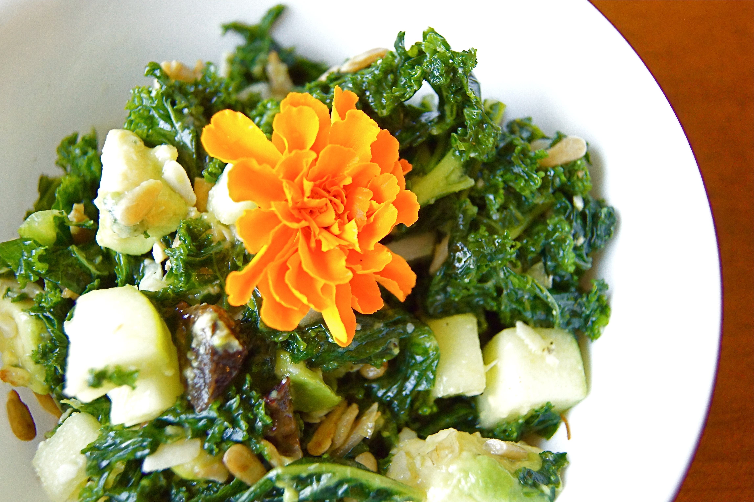

Recipe from "Feeding the Whole Family: Cooking with Whole Foods" by Cynthia Lair

Watch her cooking demonstrations at cookusinterruptus.com

**Preparation:**

1. De-stem kale by pulling leaves away from the stems. Wash leaves, spin or pat dry. Stack leaves, roll up and cut into thin ribbons (chiffonade).
2. Put kale in a large mixing bowl and add salt. Massage salt into kale with your hands for 2 minutes.
3. To toast sunflower seeds, put in a dry skillet over low to medium heat and stir constantly for a few minutes until they change color and give off a nutty aroma.
4. Stir onion, currants, apple and toasted seeds into kale.
5. Dress with oil and vinegar. Taste for salt and vinegar, adding more if necessary.
6. When at desired flavor, toss in cheese. This salad will keep for several days and still be great!

Makes 6 servings

Prep Time: 15 minutes

**Ingredients:**

1 bunch of kale

1 teaspoon sea salt

1/3 cup toasted sunflower seeds

1/4 cup diced red onion

1/3 cup dried currants

3/4 cup diced apple

1/4 cup olive oil

2 tablespoons unfiltered apple cider vinegar

1/3 cup crumbled Gorgonzola cheese

**For more recipes and information, follow**

**Virginia Mason on Facebook and Twitter!**

**Want more kale in your diet? Try these simple and delicious ways to prepare it!**

**Sautéed kale:** Heat 4 teaspoons olive oil in a large skillet. Add chopped stems, cook until softened.Add torn or chopped kale and cook, stirring, until wilted. Season with salt and pepper. Try adding a squeeze of lemon juice.

**Kale chips:** Preheat oven to 300 degrees F.Line a large baking sheet with parchment paper. Place torn kale leaves on baking sheet. Brush with 1 tablespoon olive oil and sprinkle with 1/4 teaspoon salt.

Nutrition Facts for a 6 ounce serving

Sodium: 448 mg

Cholesterol: 3.6 mg

Saturated Fat: 4 grams

Monounsaturated Fat: 7 grams

Polyunsaturated Fat: 3 grams

Calories: 188

Total Fat: 15 grams

Protein: 5 grams

Carbohydrate: 12 grams

Fiber: 3 grams

# Recipe of the Week: Massaged Kale and Currant Salad