###### Virginia Mason Medical Center, 925 Seneca Street, Seattle, WA 98101 VirginiaMason.org

August 9, 2013

This Week at the Market



**Health Highlight: Salmon**

Salmon has become well-known as a very good source of omega 3 fatty acids, and 4 oz provides 61 percent of your daily requirements of this essential fatty acid. Omega 3 fatty acids have been shown, among other things, to reduce inflammation, promote healthy blood-lipid levels, inhibit the thickening of arteries and prevent excessive clotting in the blood.

Salmon is also an excellent source of vitamin B12, tryptophan and vitamin D.

Vitamin B12 is essential for brain and nervous system health as well as the creation of healthy red blood cells.

Tryptophan, one of the 10 essential amino acids that our body needs to build proteins, also helps regulate healthy sleep patterns, elevates mood and helps stabilize appetite.

Vitamin D is necessary in maintaining normal levels of calcium and phosphorus in the blood. It aids in the absorption of calcium and works with calcium to increase bone mineral density. It has also been shown to play a protective role against various disease states.

Salmon farming in the Atlantic Ocean has been found to be associated with numerous environmental concerns, including water pollution, chemical use, parasites and disease.

The Environmental Defense Fund has issued a health advisory for farmed Atlantic salmon due to high levels of PCBs found in the meat.

Seafood Watch recommends choosing wild-caught salmon or U.S.-farmed freshwater Coho salmon. Visit montereybayaquarium.org to learn more.

Virginia Mason is Committed to Healthy Oceans!

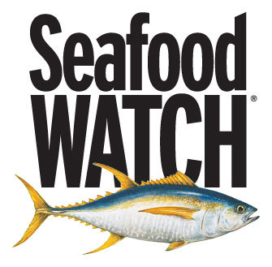

No part of the ocean remains unaffected by humans, with the fishing industry having the greatest impact. Nearly 85 percent of the world’s oceans have been overfished.

As technology has advanced our impact on the oceanic ecosystem has increased, putting our oceans on the brink of a “silent collapse”, as stated by the Pews Ocean Commission in 2003. This collapse would not only threaten our food supply; but also the world’s oceans regulate the earth’s temperature, provide livelihood for millions of people, offer a place of recreation and rejuvenation as well as provide a home to millions of species. Through better fishing practices we can make a difference.

Seafood watch, a program through the Monterey Bay Aquarium, helps consumers make choices that promote healthy oceans. Through their science-based and peer-reviewed recommendations, consumers are able to identify which options are “best choices”, “good alternatives” and which they should “avoid”. They have created a small pocket guide and an easy-to-use app for your smart phone based on region to make choosing sustainably harvested seafood easy no matter where you are.

Stacey Reyes, purchasing assistant at Virginia Mason Medical Center, follows these recommendations when choosing seafood that will be served in the hospital.

**The Virginia Mason Farmers Market**

**Is sponsored by EnviroMason**

**VirginiaMason.org/enviromason**



Makes 4 servings

Prep Time: 15 minutes

**Ingredients:**

1 tablespoon olive oil

1 tablespoon finely chopped herbs: any combination of thyme, basil, garlic, parsley, and mint

salt & pepper

2 (8-ounce) salmon fillets

1 tablespoon Dijon mustard

1/4 teaspoon wasabi powder

2 sheets nori

Watch her cooking demonstrations at cookusinterruptus.com

Recipe from "Feeding the Whole Family: Cooking with Whole Foods" by Cynthia Lair

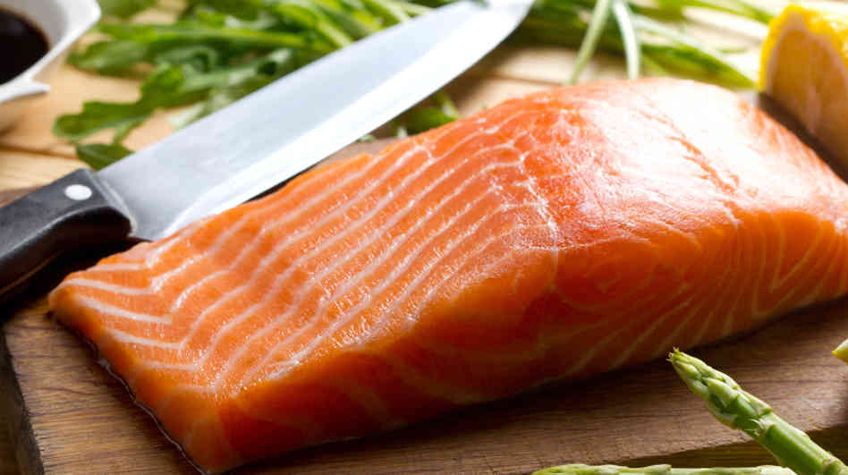

**Preparation:**

1. Preheat oven to 450 degrees F.

2. Mix oil, herbs, and salt and pepper to taste.

Rub salmon with mixture.

3. Mix mustard and wasabi together. Spread on nori.

4. Place salmon face down in the middle of the nori sheet

and wrap like a package so that fish is fully covered.

5. The nori will stick to itself and the salmon.

6. Place wrapped salmon in a lightly oil baking dish.

7. The general rule for fish is to cook it 10 minutes for each

inch of thickness. The nori will lightly flavor the salmon

and seal in the juices.

Sodium: 192 mg

Cholesterol: 67 mg

Saturated Fat: 3 grams

Monounsaturated Fat: 7 grams

Polyunsaturated Fat: 5 grams

Calories: 254

Total Fat: 16 grams

Protein: 24 grams

Carbohydrate: 2.7 grams

Fiber: 0.75 grams

**“The Super Green List”**

Seafood Watch understands the important role seafood plays in a healthy diet, specifically as a great source of omega 3 fats. For this reason they have created The Super Green List, which combines the work of conservation and public health organizations, to provide recommendations that are healthy choices for humans and the ocean. These recommendations include species which are plentiful, caught or farmed in environmentally friendly ways, low in environmental contaminants (such as mercury and PCBs) and are good sources of omega 3 fatty acids.

The seafood which holds the top ranks on The Green List includes U.S. or British Columbia Albacore tuna that was troll- or pole-caught, U.S. Freshwater Coho salmon that was farmed in tank systems, farmed oysters and

wild-caught Alaskan salmon. Visit montereybayaquarium.org to learn more.

**For more recipes and information, follow**

**Virginia Mason on Facebook and Twitter!**

Nutrition Facts

**For more information on what’s fresh and local**

**visit pugetsoundfresh.org**

# Recipe of the Week: Nori-Wrapped Wasabi Salmon