At farmers markets placement of vendors is vital

At farmers markets, location of vendors strikes balance that benefits buyers and sellers
- PREVIOUS
- NEXT
- 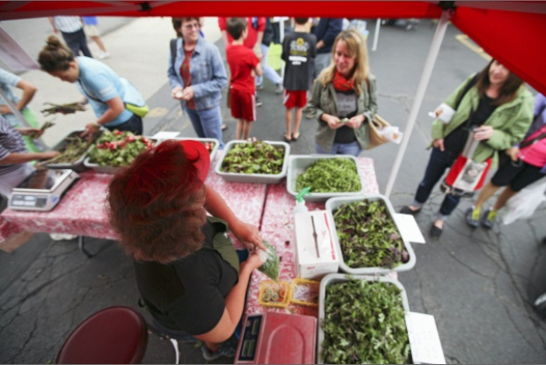
ALEX HOLT | DISPATCH PHOTOS
Joan Richmond of Meadow Rise Farm sells her produce at the Clintonville Farmers’ Market.
- 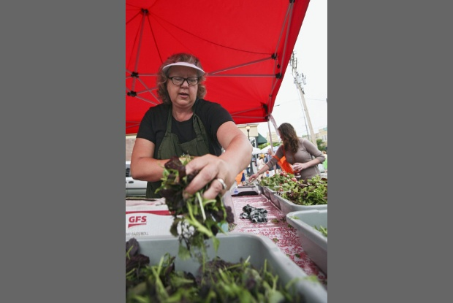
Joan Richmond grabs a handful of spicy greens for a customer.
- 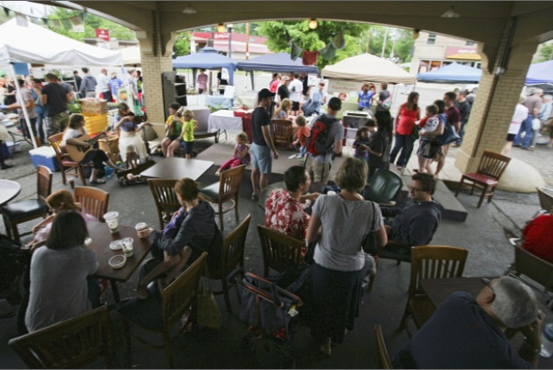
ALEX HOLT | DISPATCH PHOTOS
The Clintonville Farmers’ Market on N. High Street — viewed from Global Gallery — attracts large crowds on Saturdays.
- 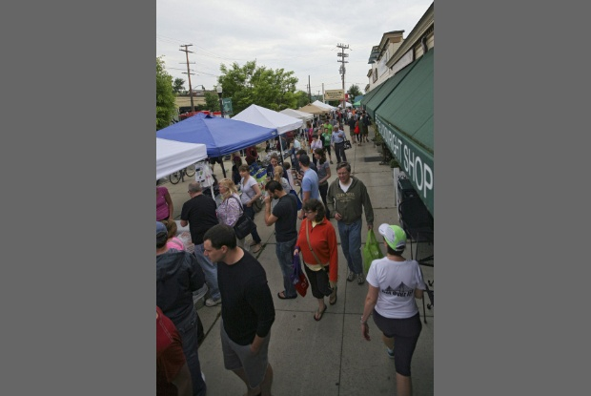
Saturday shoppers crowd the sidewalks along N. High Street for the Clintonville market.

By Robin Davis
Dispatch Kitchen Wednesday May 22, 2013 6:41 AM
Long before customers arrive at a farmers market and map out a plan of attack, the market managers and farmers engage in a little choreography of their own.
The managers carefully arrange vendors, aiming to provide an appealing mix for customers — so the market doesn’t offer stall after stall of, say, ripe red tomatoes.
The farmers, meanwhile, seek to secure a high-traffic spot in the hope of selling all or most of their goods.
Each market season, from mid-May to early or late October, the dance between the two becomes a delicate balancing act that, on the best days, plays out harmoniously.
“It tends to work organically,” Linda Foor, manager of the Uptown Westerville Farmers Market, said of the selection and placement of vendors.
To attract customers, she said, she tries to put a vendor selling flowers near the street bordering the parking lot of the market — open on Wednesdays.
She intersperses the 20 or so other stalls, she said, by “sweet” (fruits and baked goods) and “savory” (cheese and vegetables).
At larger markets, the vendor arrangement gets more complicated.
Laura Zimmerman manages the Clintonville Farmers’ Market — where, at its peak on Saturday mornings, 52 vendors line the west side of N. High Street from Orchard Lane to Dunedin Road.
“The primary factor is creating a good mix within the market,” she said. “I don’t want to put two maple-syrup producers next to each other. But we might put a baker next to a jam-maker.
“Part of it is producer requests,” she said, referring to the farmers and vendors.
Joan Richmond of Meadow Rise Farm in Richland County prefers the Donatos parking lot, at the Orchard Lane end of the market — where she creates a little courtyard.
“I can sell from three sides of the booth,” she said. “That’s been fabulous for me. When I have everything in August and September — heirloom tomatoes, squash and greens — it helps me to be able to have the booth space.”
When a producer resists a stall placement, Zimmerman said, she tries to resolve the problem.“I don’t have a waiting list for a single spot,” she said, but some spots better suit certain producers.
Mary Bridgman of Bridgman Farm in Washington Court House, for example, didn’t like her location in front of Global Gallery — for physical reasons.
“There’s a grassy knoll there,” she said. “Everything is at a slant. When we would weigh the tomatoes, they would roll off the scale.”
Zimmerman moved her this year to the front of Karen Wickliff Books, where, on level ground, Bridgman sells chard, turnips, radishes and — later in the season — dozens of varieties of tomatoes.
Overall, though, Bridgman thinks the location matters less at crowded markets such as Clintonville.
“At a busy market, the more customers you have, the less it matters where the stall is,” she said. “At the smaller markets, there are fewer people and the gateway stall is important.”
At the smaller North Market farmers market, where she also sells on Saturday mornings, Bridgman struggled with various locations.
“At North Market, I think a gateway spot (near one of the entrances from the parking lot) helps,” she said.
After moving four or five times, she said, she is satisfied next to Rhoads Farm, just one spot from the central entrance.
Market manager Peggy Outcalt, meanwhile, thinks the smallness of the North Market effort makes location there less important.
“The shoppers walk the entire farmers market,” she said. “They develop relationships to the farmers. That determines more for the customer than the location.”
Most of the market managers consider the consistency of a location one of the biggest draws for farmers.
“Once we place a vendor, we try to keep them in the same spot,” said Foor, of Westerville. “It helps them immensely to be in the same spot.”
Adam Schroeder, manager of the Pearl Market, agrees.
“A customer may not remember a name or a face or a logo, but they’ll walk to the same area,” he said of the customers at the Downtown market, on Tuesday and Friday afternoons in Pearl Alley.
Location consistency poses a challenge at the Worthington Farmers Market, Jaime Moore said.
Richmond of Meadow Rise Farm, new this year to the popular Saturday morning market, might have to change spots three or four times, Moore acknowledged.
Participation in the mammoth market, however, is worth the trouble, Richmond said.
“You pay your dues,” she said.
Moore has a waiting list of 30 to 40 vendors who want to join the 80-plus who already line the quarter-mile of High Street from Dublin-Granville Road south to well past New England Avenue.
“We’ve added about 20 new vendors this year, although they’re not all weekly,” she said. “Some are completely unique: a frozen-fruit Popsicle vendor, frozen dessert person (dairy-free, nut-free). We’ve added things that are completely different.”
Market organizers, Moore said, are trying to build up the southwest side.
“That’s the newest area,” she said. “We put a larger farm, like Rhoads Farm, at that end. We intersperse some of the new vendors — like Kingdom Fish and a new pork producer — so people realize there are benefits to traveling all corners of the market.”
Still, the veteran vendors do have their preferences, Moore said.
The most-requested spaces border the crosswalks with stoplights, which yield a captive audience.
“Everybody has a vision of what they believe to be the best space.”
Moore, co-owner of Wayward Seed Farm in Marysville , finds herself in an unusual position: She not only manages three markets — Worthington, the Bexley Farmers’ Market (Thursdays) and the Dublin Farmers’ Market (Wednesdays) — but also sells goods at all three and at Clintonville.
The Wayward Seed Farm space at the Worthington market is in the lot at High Street and New England, in front of House Wines — an area less deep but a little longer than others.
“Quite frankly, we love our space,” she said.
“But it’s really what people do to make the best of it. There’s no rhyme or reason.”
robin.davis@dispatch.com
@DispatchKitchen

Link to article: http://www.dispatch.com/content/stories/food/2013/05/22/stands-to-reason.html

