So You Want to Be A Farmer…
Ever dream of chucking it all for the simple life? Read this first.
By Jesse Hirsch, Modern Farmer, on September 15, 2014
Illustrations by Julia Rothman
“Sorry — you’re low man on the totem pole.”
With those words, farmer Eliza Winters dispatched me to the field. I was on rock duty — a tough job on any day, but especially on this muggy June afternoon, with nary a cloud to block the sun.
Winters’ Hill Hollow Farm is situated in upstate New York, a region infamous for its stony topsoil. Being on rock duty meant that I had to hustle behind a tractor, hoist rocks from the newly tilled dirt and toss them in the front bucket. The work was monotonous and exhausting. At one point I lost my (poorly chosen) slip-on sneakers in the mud, forcing me to go elbow-deep to excavate. Several hours later, every muscle ached; my skin was caked with soil and sweat. My first day on the farm was rough.
Farming dreams are a modern seduction. For city dwellers, the vision of making a living from the earth salves the psychic wounds of a day job, and acts as an antidote to urban malaise. If you could just get out there on the land, far from spreadsheets and stress, cubicles and car alarms, things would surely be different. Eating overripe tomatoes, fresh from the vine and bursting with juice. Cavorting with goats.
This is the life you were meant to live. In your heart and soul, you’re a farmer.
But there’s a big difference between ogling barn listings online and standing knee-deep in pig manure. As farmer and agricultural consultant Rebecca Thistlethwaite — who gives “bootstrapping” seminars to aspiring new farmers — puts it, the vision of “sitting in a lawn chair, overlooking the pasture, raising a glass of wine” is fodder for a rude awakening. How do you negotiate the gap between farm fantasy and reality?
Over the last few decades, the global trend in developed nations has skewed towards bigger, more consolidated farm operations. Yet here in the U.S. — where the vast majority of our 2.1 million farms are classified as small (in terms of sales) — there has also been a steady increase in smaller, community supported agriculture (CSA) farms. Hoping to encourage this trend, a host of government-sponsored small farming initiatives have sprung up around the globe, from Japan to India to the U.K.
For this story, I spent a summer week at Hill Hollow in Petersburgh, New York, a two-year-old CSA farm producing organic veggies, pork, beef, chicken and eggs. My goal was to ingest the rhythms and routines of daily farm life — separating the facts from the fantasy — but also to learn the logistics of a transition to farming.
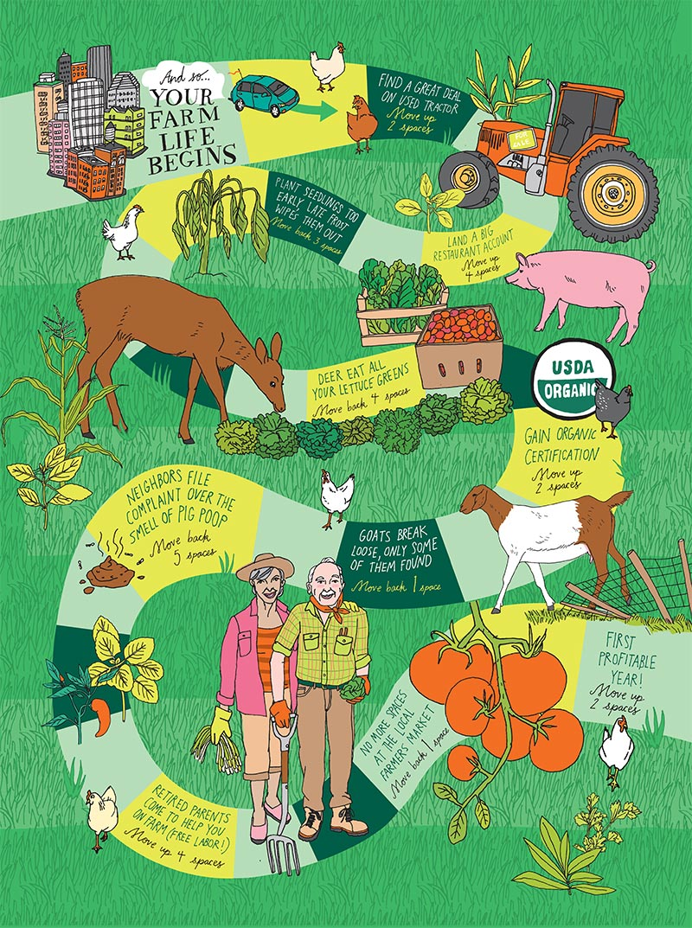

Learning the Ropes
Most large-scale commodity farms are family operations. In Nebraska and Iowa, it’s not uncommon to meet sixth-generation corn and soybean farmers. On this type of farm, skills and technical knowledge are passed on from parent to child. But new, small-scale farmers come from all walks of life; skills must be acquired, not inherited. The first step towards deciding if you want to chuck it all and move to the country is to actually spend time on a working farm.
Many small farms take in apprentices or interns (a largely semantic distinction) for a growing season. According to Thistlethwaite, this is an all but mandatory step in your farm journey. And not just for one season. She suggests apprenticing for three to four years before you even consider starting your own farm. This will not only provide a basic knowledge base, but also ensure that farming is something you enjoy. “[Apprenticing] is gut check time,” she says. “It gives you the chance to ask yourself: ‘Is this really who I am?’”
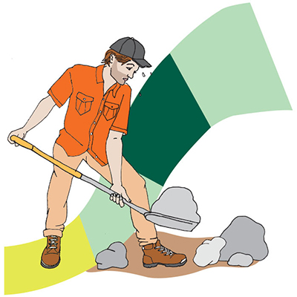

Resources For New Farmers
- The Greenhorns’ Field Guide for Beginning Farmers.The Greenhorns are a grassroots nonprofit started by Severine von Tscharner Fleming, with the goal of replacing our current agricultural system with smaller, sustainable farms. Their PDF field guide is loaded with practical advice on everything from farm fitness to farmers market best practices. Bonus: charming illustrations.
- The Practical Guide to WWOOFing.World Wide Opportunities on Organic Farms (WWOOF) is a wildly popular way to log time on organic farms around the globe, without the commitment of a full apprenticeship. Adam Greenman’s self-published “The Practical Guide to WWOOFing” tells you everything a new WWOOFer needs to know, right down to the best knife to bring and boots to wear.
- Farms With a Future.Farmer and consultant Rebecca Thistlethwaite traveled around the U.S. talking to sustain- able small farmers, learning their challenges and successes. “Farms With a Future” (Chelsea Green, 2012) details these stories, including Hill Hollow Farm’s, while giving step-by-step practical advice to new and growing farmers. Also check out Thistlethwaite’s soon-to-be-published book, “The New Meat Market.”
- National Young Farmers Coalition (NYFC).The NYFC “represents, mobilizes, and engages young farmers to ensure their success,” according to its website. This site is an excellent starting point for the budding farmer, loaded with information on funding and local resources.
- Local Ag Extension Offices.Ag extension is a decades-old system for helping farmers on a local level and it’s still worth checking out today. Your extension agent can provide vital information, from local soil quality to tips on equipment purchasing. Visit the website to find your nearest office.
Alternately, you can glean your lessons at a handful of global “farm schools” for a price tag of up to $18,000. This path provides a higher prestige factor, not to mention bonus skills like foraging and wildflower cuisine. But since most farm internships cover room and board, and pay a stipend for your work, it may be hard to justify farm school’s expense.
This summer, Hill Hollow had two young interns fresh from Colorado, and a 19-year-old volunteer with the World Wide Opportunities on Organic Farms program (aka a WWOOFer). Apprentice programs can be a bonus for farmers in need of labor, but at Hill Hollow the help is vital. Eliza Winters’ husband, Nathan, passed away this spring after a freak ATV accident. The timing couldn’t have been worse: When I visited, Winters was pregnant and also caring for a 15-month-old baby, struggling to get out of the red and running a farm on her own. Without apprentices, it’s hard to fathom how she would manage.
Interns Hallie Swain and Miles Griffin arrived the week before I did, after loading their goods (i.e., two hamsters and an assortment of sun hats) into Griffin’s pickup and heading East. Swain had already interned on farms in Montana, Washington and Colorado.
Farm apprenticeship is like a well-rounded liberal arts education. In just one summer, Hill Hollow’s interns will master a survey of baseline skills, like planting, harvesting, weeding, feeding animals and collecting eggs. They’ll also pick up some next-level lessons, like protecting crops from roving deer, chicken evisceration and rounding up runaway pigs. Swain will even have the chance to manage Hill Hollow’s CSA program, a window into the public face of farming.

Finding Your Own Farm
You could always keep working on other people’s farms, leaving the high-level stress to someone else. Take Swain for instance. Her eventual goal is to start an educational farm with Griffin, but fear keeps her from taking the plunge. “The idea of running something like this is terrifying!” she says, gesturing around at Hill Hollow. “It’s much easier to have someone tell you what to do and where to go.”
But let’s assume you’re ready. First, you have to decide whether you want to purchase your own land. Lindsey Lusher Shute, co-founder of the National Young Farmers Coalition, advises new farmers to lease before they buy, a good way to learn about an area before you go all in.
But leasing comes with its downside, too. You’re at the mercy of landlords, most of whom are not farmers themselves (88 percent, according to NYFC). This can lead to conflicts, where the property owner’s priorities don’t match up with the farmer’s. Take the Winters: They ran another farm before Hill Hollow, on a leased parcel of land in Vermont. There were issues, but manageable ones, until their landlord decided he didn’t want livestock on his property. They ultimately got booted from the land they were farming. “Very few landowners are willing to work with you, to help invest in your farm,” says Shute. “Farmers need long-term land tenure.”
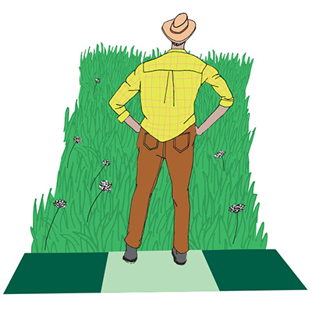
When you are ready to buy, you’ll probably have some target locale in mind, such as the lush Bay Area or the rolling hills of New York’s Hudson Valley. You will likely have to dial those dreams back a bit. According to the USDA, farmland prices doubled from 2000 to 2010 across the U.S. Any farmland near a desirable city is going to cost much, much more (parallel to real estate prices in actual cities). You’re competing for the built-in locavore customer base in Brooklyn and San Francisco. And if you’re in commuting distance of a big city, good luck even finding farm acreage. Raw suburban land is often snapped up for residential and commercial development.
The catch-22 is that you will need some populated nexus if you want to sell your farm products. It’s a delicate balance. Thistlethwaite has a running list of cities that could use more nearby farms. Lincoln, Nebraska. Des Moines, Iowa. Boise, Idaho. Mobile, Alabama. Grand Junction, Colorado. They may not be the sexiest spots, but buying nearby farmland is a wise bet. “Of course, every young farmer wants to be in a place where there’s a lot of people like themselves,” says Thistlethwaite. “But if you’re willing to move to a less desirable area, you could be the first wave of their local food movement.”
Even with a strategic location in mind, finding a piece of land can take time. Craigslist has yet to be a viable resource for farms, and websites like LandAndFarm tend to only feature high-end boutique properties. At this point, one of the best ways to find a parcel is word-of-mouth — getting to know farmers in your desired area. Chat them up at the local farmers market, let them know you’re scouting for land, and definitely hit up local real estate agents. It’s an IRL social network.
And what of financing your farm? On top of the property itself, you’re going to need money for equipment ranging from hand tools to tractors, not to mention a deluge of small expenses that add up fast: boots, egg cartons, fencing, mulch. There are creative solutions, though. Some of these costs can be mitigated by borrowing equipment from neighbors,or accruing more tools once you start pulling in income. Traditional banks may not lend to a new farmer (it’s seen as a risky venture), but you can always fib to the lender and tell them you’re buying property to live on. (That is, as long as it doesn’t jeopardize your homeowner’s insurance or violate local zoning rules.) “Once the keys are yours, you can just start farming,” says Thistlethwaite. But there are other options. The USDA’s Farm Service Agency gives loans of up to $300,000 for prospective farmers, with a funny caveat: To qualify, according to Thistlethwaite, you must have been turned down by three conventional banks.
Another option is signing up a roster of CSA customers in advance of starting your farm. Shute’s husband Ben runs a farm that started this way. And depending on where you want to farm, there are region-specific funding sources. For instance, Farm Credit East is a century old lending institution for farmers in seven northeastern states. A nonprofit called California FarmLink gives direct loans up to $250,000, on top of a range of other creative financing options. Check with your local ag extension office to see what’s available in your area.

The Experimentation Phase
Once you’ve actually secured some land, the fun begins. It will take time to figure out the idiosyncrasies of your farm and its customer base. Not to mention that even after years of apprenticing, there’s a steep learning curve.
In the first year at Hill Hollow, the Winters spread composted manure over many of their crops. Turns out the fertilizer still had hayseeds in it; grasses sprung up all over, choking out much of their produce. They lost 60 percent of their crops that year, and more than half of their CSA customers would not return.
“I cried every single day,” says Winters. “How do you bounce back from that?”
Another teaching moment came when the Winters tried raising quasi-heritage breed chickens called Freedom Rangers. Heritage birds are all the rage, and the Freedom Rangers cut a handsome figure on the pasture, but there was a problem: Hill Hollow’s customers didn’t like the taste. Not only was the meat a bit tough, it didn’t have the familiar “chicken taste” people expect (a common gripe about pastured heritage birds). This year, Winters raised good old Cornish Cross chickens, and hasn’t heard a complaint yet.
One day, some friends from a Massachusetts farm called Square Roots arrived to help Winters with her chicken slaughter. They brought with them an awesomely efficient mobile slaughtering and packaging operation, the likes of which made the Hill Hollow crew envious. More importantly, Winters and crew took note. Could they replicate that six-pronged PVC pipe, perfect for holding up chicken carcasses? What about that simple system of boiling water to quickly shrink-wrap each bird? These flourishes were quickly adopted at Hill Hollow.

Scaling Up
(or Winding Down)
Somehow you’ve managed to keep the farm going for a few growing seasons. What now?
In 2014, it’s no great shock that social media has become a vital weapon in a farmer’s marketing arsenal. Some farmers, like the “>Beekman Boys and the Peterson Farm Brothers, have accrued online fans in the hundreds of thousands. But even on a modest level, social media is a great bridge between farms and consumers. Michael Gallagher of Square Roots Farm sums it up: “It’s a mix. We can show customers the pretty parts of farm life, but we can also just give useful info on CSA pickups.”
Outside of social media you can hammer out other ways to market your farm goods, from cold calling restaurants to building a roadside stand. A new farm in Russell, Massachusetts, recently put coupons in the local paper, good for a free dozen eggs (the catch: you have to pick them up at the farm). You can also try cooperative marketing schemes, teaming up with other local farmers to maximize reach, or offering meat shares, where multiple customers go in on one whole beast.
To boost revenues, you can extend your growing season with hoop houses and greenhouses (leafy greens will always find a market in winter). Value-added products — like turning bruised peaches into jam, tomatoes into marinara — also help pad the coffers. And though you may loathe farm tourism (weddings and the like), this route has certainly proven lucrative for picturesque properties.
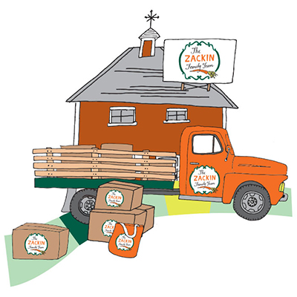
And at this point, as hard as it is to accept, there’s another path available as well: letting the farm go. For reasons ranging from economics to exhaustion, this may be the path you end up choosing. Thistlethwaite, though a major advocate for new farmers, ended upselling her Bay Area working farm after 300 chickens and a rototiller were stolen (among other issues). Now in Oregon, she is a consultant and an author. “I tried being a full-time farmer; the stress was unbelievable!” she recalls. “We felt like hamsters on a wheel. I’m so happy to only do it half-time.”
During my stint at Hill Hollow, I often wanted to throw in the towel, when farm work seemed like sheer drudgery, tedious tasks stretching out to infinity. I shocked myself multiple times on electric fencing. My sunburnt skin took the shade of a country ham. Everything hurt. I spent one long day on my knees in the mud, mounding up long rows of soil. That night I lay awake on a foam mattress, miles of dirt streaming behind my eyelids. Another day, I had to muck out the deep crust of piss and shit from a sweltering pig barn. Sheer force of will kept my breakfast down.
And yet — I felt great. There were moments of transcendence: watching piglets frolic in a pasture for the first time, or quietly weeding while honeybees buzzed about. But even beyond that, there was something purifying and warm about all the hard work, something that washed away the static in my head. “Since Nathan died, farming has been incredibly healing to me; some days it’s the only thing keeping me together,” says Winters. “It’s hard to put into words. Farming just gets in your blood.”
Is it for everyone? Certainly not. Even Shute, who spends her waking hours advising would-be farmers, admits that some of the most enthusiastic rookies aren’t going to like it. Farming is arduous and monumentally stressful, with a payoff that can be thin at best.
“You won’t know what it’s like until you’re soaked with sweat and you wanna cry because you have another 100 feet of vegetables to weed,” she laughs. “That’s not something you can get from watching a nice farm video.” But once you give it a shot, there’s a chance you won’t be able to let it go.
Later this summer, I plan to return to Hill Hollow for another bout of work. This time, I won’t have a story to write.

Farmers Needed!
According to farming consultant Rebecca Thistlethwaite, there are still some U.S. cities that haven’t been oversaturated with small-scale farmers (e.g., Madison, Wisconsin, which has a five-year wait for a farmers market booth). If you’re willing to relocate, see if you can track down arable land near one of these American cities. They need you!
–> Lawrence, Kansas
–> Mobile, Alabama
–> Moscow, Idaho
–> Gainesville, Florida
–> Lincoln, Nebraska
–> Grand Junction, Colorado
–> Fayetteville, Arkansas
–> St. Louis, Missouri
FEATURE

