Hobby Farms.com

6 Questions You Should Know How to Answer at the Farmers' Market

Don’t be caught off guard by customer curiosity. Prepare your response to these questions before market day.

By Jesse Frost

1
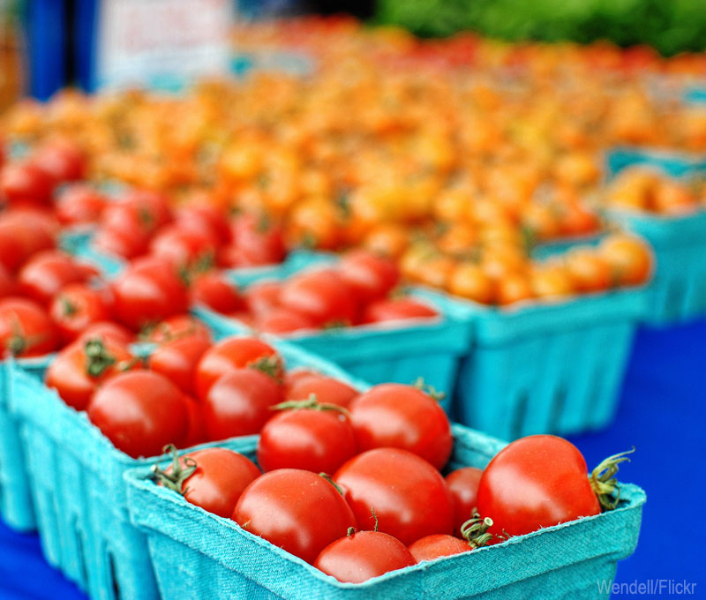
Courtesy Wendell/Flickr
The farmers' market is filled with a wide variety of people, from experienced cooks and chefs to customers just getting into local food, and they all come with their own set of questions. Your ability to answer these myriad inqueries can translate directly to market sales, encouraging the customers to come back time and again because you’re trustworthy and helpful.
If you’re planning to head to market with your produce or meat, here are six common questions you might hear.
1. Are you organic?/Do you spray?
Technically, to be Certified Organic, you must apply for and follow the rules of the USDA's National Organic Program, at which point you are awarded organic certification. You can legally use the term "organic” to describe your food only if you have gone through this process.
But what if you follow organic principles and are not certified? Simply explain that to your customers. Explain that you don’t use chemicals and prefer biological solutions for pests and weeds, but have chosen not to be or have not yet been certified. Most customers respond well to this answer.
"Do you spray?" is a similar question but more to the point. Simply tell them if you do or do not use chemicals. If they ask further, you can explain which ones you use (if any), how you apply them and how they affect your farm environment.
2. Did you grow these yourself?/Are these veggies homegrown?
Some markets allow their vendors to buy food wholesale then resell it. However, people often like to buy food from the farmer and will ask you if you grew or raised it yourself. They’re likely asking just to make sure you didn’t purchase from another farmer.
3. What's the difference between these _____?
Customers will fill in the blank with anything from tomatoes, garlic, cuts of meat or different-colored eggs. You should have a good idea of the taste characteristics of different varieties of produce, meat or eggs and how they cook in comparison to one another. Before going to market, taste-test what you plan to sell. Sometimes the difference may be negligible, but a lot of times the customer just wants to know if they should be buying one over the other. If you haven't yet had a chance to taste everything, you can always ask other farmers who grow the same varieties what they think, or ask customers what they like to do with the items they buy.
4. How do you prepare this?
It's a good idea to have one recipe you enjoy in mind for each item you sell and a basic understanding of how it’s typically prepared. If you are not a fan of a certain vegetable or cut, that's OK—peruse cookbooks for seasonal dishes others can prepare easily. Even if you don’t come to market with detailed recipes, offering a few ideas for how it can be prepared or what cultures, countries and cuisines it’s most commonly associated with will help customers to envision the item's use in their kitchens.
5. Why is everything so expensive?
Trying to compete with most supermarket prices will rapidly put you out of business, so don't try. Charge what you think your food is worth and explain to the customer the work involved with your meat, produce or eggs, but how the customer is guaranteed a more flavorful and healthful product by buying from a local farmer like yourself. Also, items in the grocery store often travel thousands of miles, and can come from entire other countries and continents, whereas the food from your farm had to travel only as far as you did. Tell them that, along with anything else that goes into your pricing. Occasionally a customer will pass, but more often than not you will get a positive response, a sale and a loyal customer.
6. Are these free-range/pastured?
In regards to meat and eggs, customers may want to know how the animals were raised. "Pastured" is a newer term that refers to chickens being raised on pasture or livestock moved in a rotational grazing system. "Free-range," though a label regulated by the government, simply means the animals have access to pasture.
A customer may also ask about what you feed your animals or if you've ever given antibiotics or hormones. Be ready for savvy patrons who have very specific questions, then always be forthright and honest—the customer might have severe allergies or strong ethical oppositions to certain treatments of animals, and those issues should always be respected. Besides, a respectful and honest market farmer is a successful one.
Get more marketing tips from HobbyFarms.com:
- 8 Tips for Beginner Farmers' Market Vendors
- 11 Steps to Successful Farm Marketing
- 5 Steps to Starting a Rural Farmers' Market
- 6 Ways to Make Money Outside a Farmers' Market
- 10 Native Plants to Market
About the Author: Jesse Frost is a Kentucky farmer, blogger and author. He and his wife run a small, off-the-grid farm in southern Kentucky called Rough Draft Farmstead, where they raise vegetables and livestock naturally.

